
IDH2 (R172K)
Catalog Number: CR-M26163
Gene Symbol: IDH2 (R172K)
Description: Anti-IDH2 (R172K) Mouse Monoclonal Antibody

Background: Isocitrate dehydrogenase (IDH)
catalyze the oxidative decarboxylation of
isocitrate to 2-oxoglutarate. The isocitrate and
isopropylmalate dehydrogenases family has
three members, IDH1, IDH2 and IDH3. IDH2
plays a role in intermediary metabolism and
energy production. Defects in IDH2 are the
cause of D-2-hydroxyglutaric aciduria type 2
(D2HGA2). Somatic mosaic mutations of this
protein have also been found associated to Ollier disease and Maffucci syndrome, and R172K
IDH2 mutations do exist in diffusely infiltrative gliomas.
Immunogen: A synthetic peptide from the internal region of IDH2 which includes the mutation of R172K, human origin.
Tested applications: ELISA, WB, IHC Recommended dilutions:
ELISA: 1:1000-1:5000
WB: 1:100-1:1000
IHC: 1:10-1:100
Concentration: 1 mg/ml
Host: Mouse
Clonality: Monoclonal
Purity: Purified from ascites
Format: Liquid Storage buffer:
Preservative: no
Constituents: PBS (without Mg2+ and Ca2+), pH 7.4, 150 mM NaCl, 50% glycerol
Species Reactivity: recognizes R172K mutant, but not wild-type IDH2 of vertebrates.
Storage Conditions: Store at -20°C. Avoid

freeze / thaw cycles. Western blot:

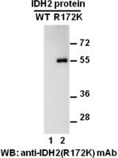

Western blot analysis of recombinant IDH2
(R172K) and wildtype proteins. Purified
His-tagged IDH2 (R172K) (lane 2) and wildtype protein (lane 1) were blotted with anti-IDH2
(R172K) monoclonal antibody (Cat. #26163).

For research use only. Not for diagnostic or therapeutic applications.

Immunofluorescence:
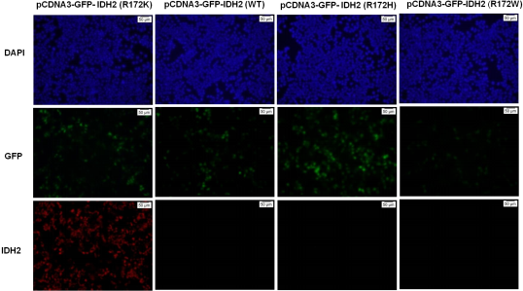

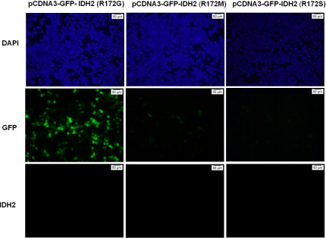
Immunofluorescence of cells expressing IDH2 proteins with anti-IDH2 (R172K) antibody.
HEK293T cells were transfected with pCDNA3-GFP- IDH2 (R172K) plasmid , pCDNA3-GFP- IDH2 (WT) plasmid, pCDNA3-GFP- IDH2 (R172H) plasmid , pCDNA3-GFP- IDH2 (R172W) plasmid, pCDNA3-GFP- IDH2 (R172G) plasmid,pCDNA3-GFP- IDH2 (R172M) plasmid or
pCDNA3-GFP- IDH2 (R172S) plasmid,
then fixed and stained with anti- IDH2 (R172K) monoclonal antibody (Cat. #26163)

